Linux Commands

1. Echo $0

To get the shell name



1. / (Forward slash)

To get the root directory



1. ~ (Tild)

To get the home directory



1. Pwd

To get the present working directory



1. mkdir ( make directory)

To create the new directory



1. ll (long listing)

To get the list of the files along with the details

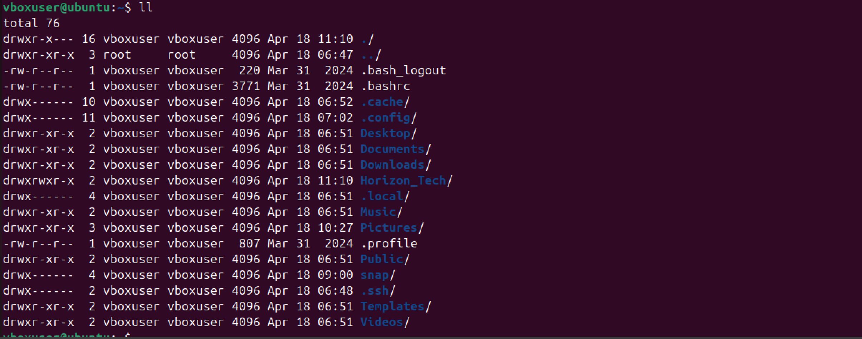

1. cd :

To change the directory



1. cd ..

To step back by one step



1. cd ../..

To step back by two steps

1. touch

To create the file( name as Sushma )in directory



1. vi

To edit the file

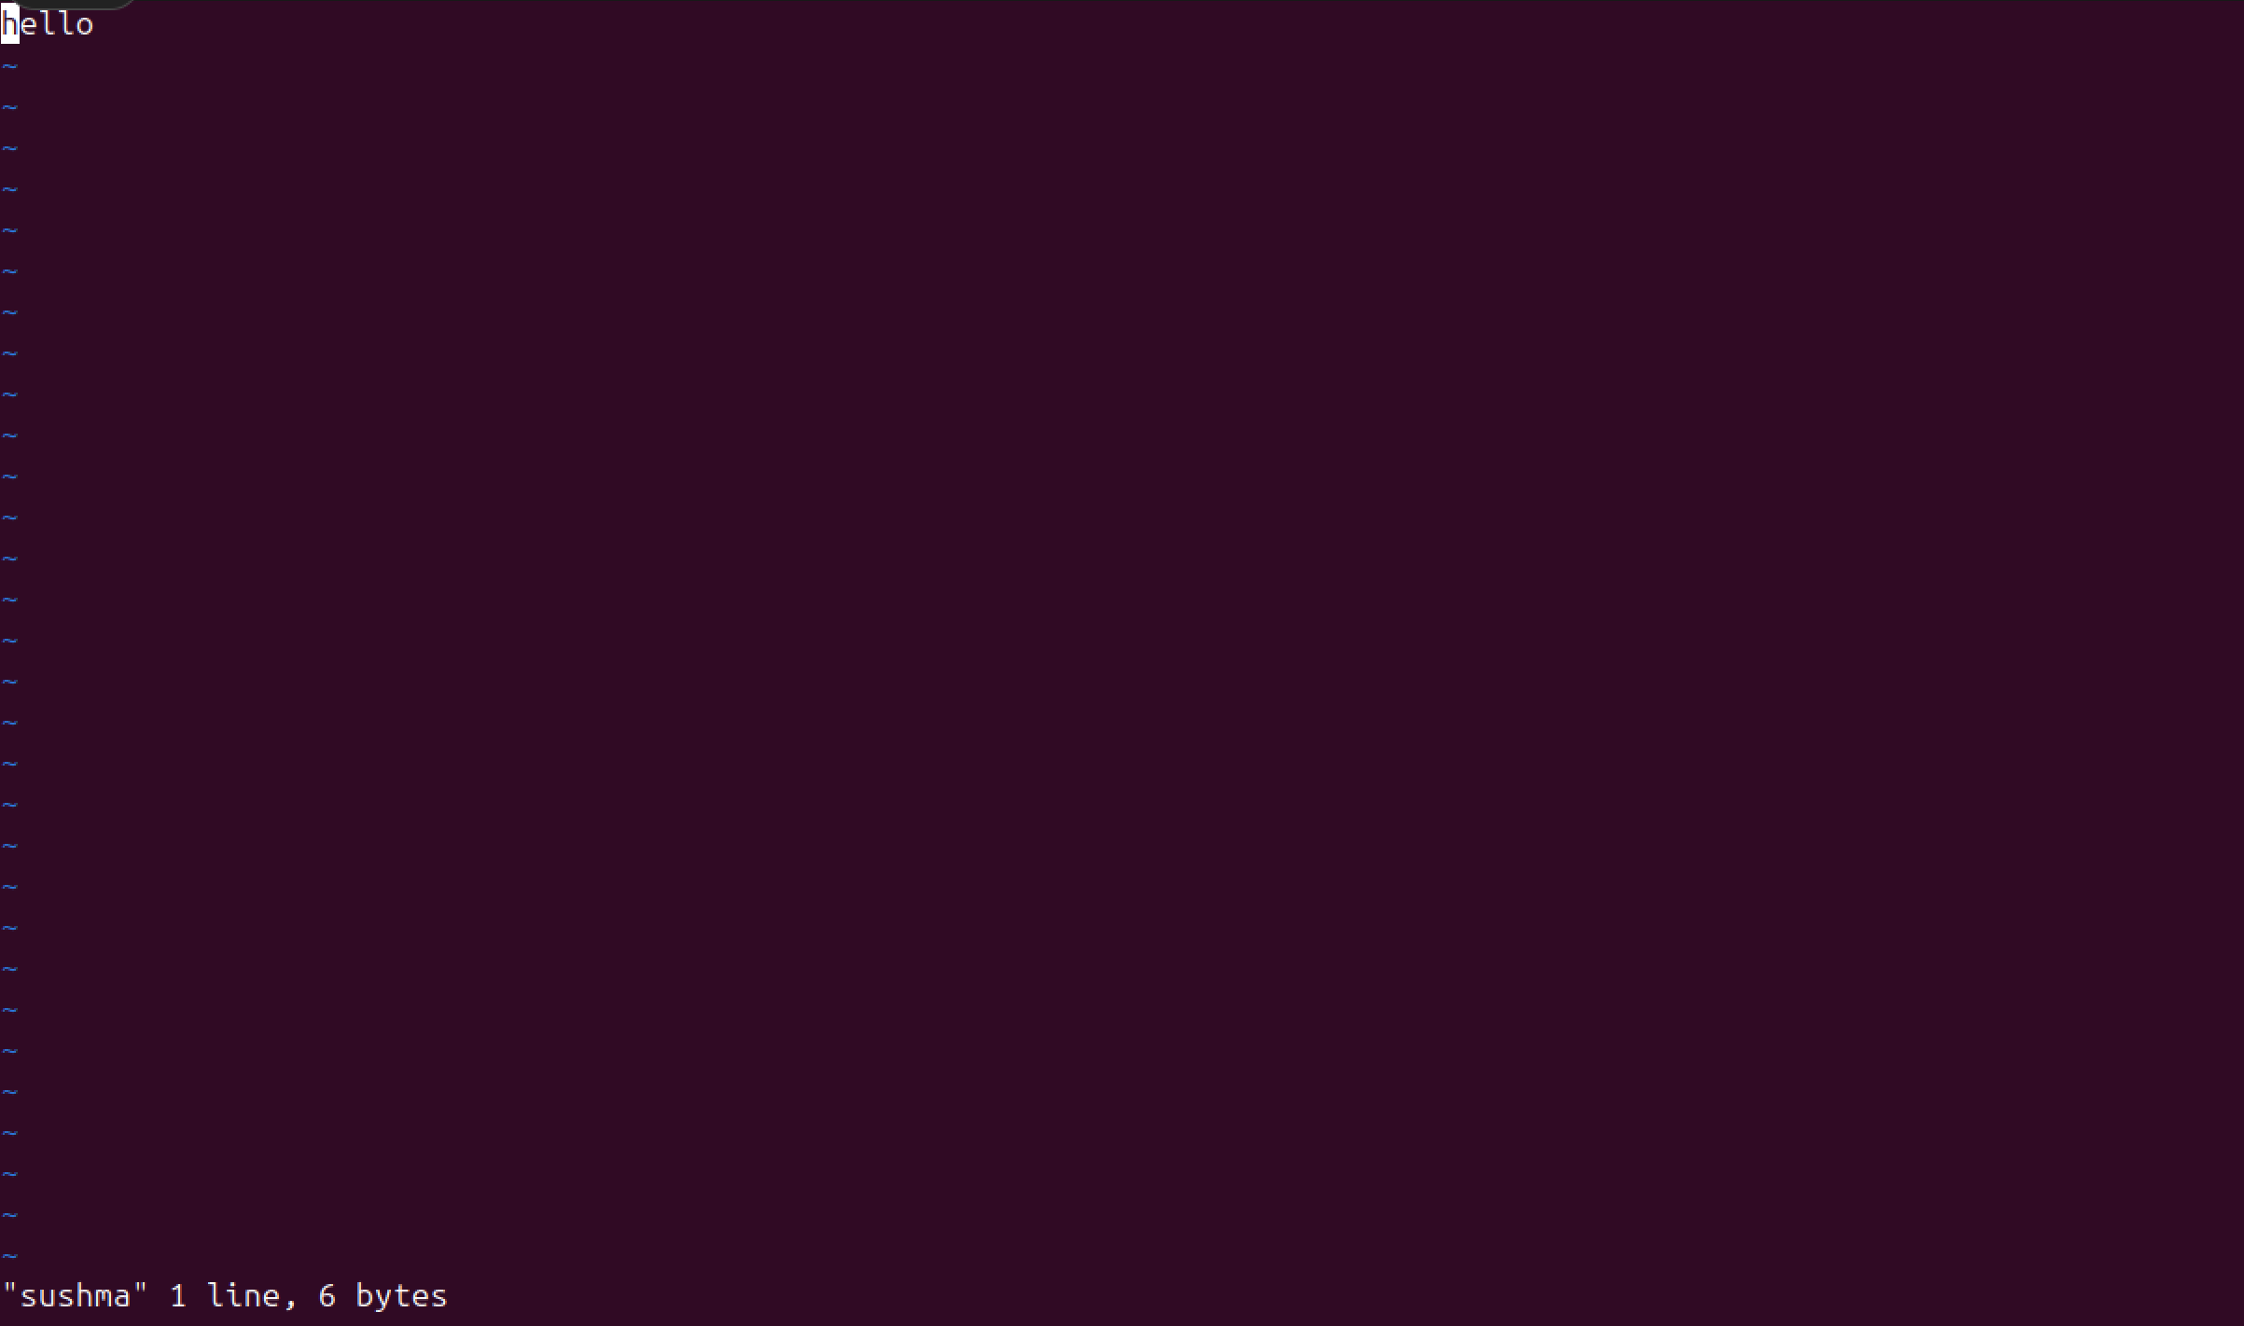

1. cat

To read the content in file



1. wc

To show the count of words, letters ,statements in the file



1. ls -d */

To get the list of all directories



1. ls -a

To get the hidden files



1. ls -ltr

List according to time

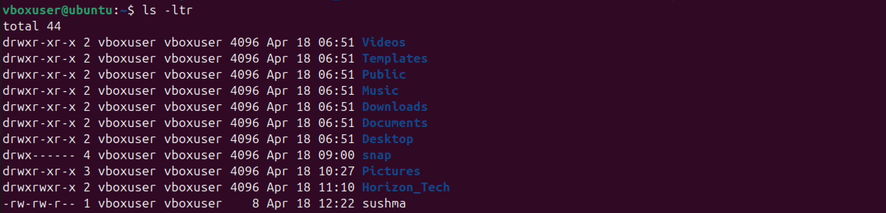

1. date

To get the date



1. rm _rf

Delete remove recursive file

